Waves and Tides Notes

**Waves**- visual proof of the transmission of energy across the ocean

* Caused by wind and the shape of the ocean floor
* Wind transfers energy from air to water molecules through friction
* Waves of water only move up & down, not horizontally

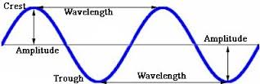

**Movement of Waves**

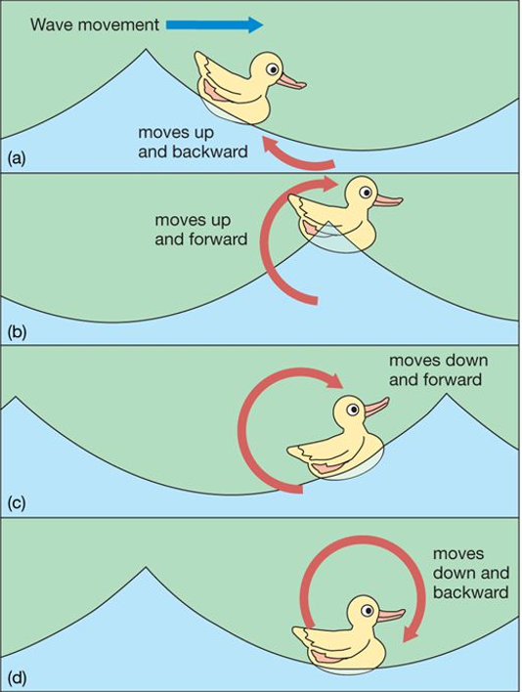

* Circular Orbital Motion
* move in a circle
* move up and down
* move back and forth

**Breakers**

* where the bottom of the wave hits the shoreline and the top keeps moving forming an arc

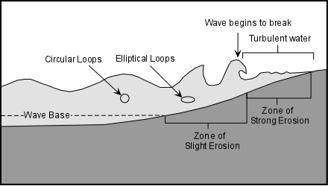

Wave Direction

* Waves start at an angle with the wind, and slow down to become parallel with the shore when breaking

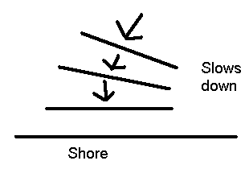

Longshore Currents

* Waves strike shore at an angle causing a current to flow parallel to the shore.

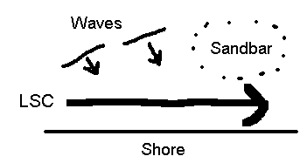

Rip Currents (aka Riptides)

* form when a sandbar is broken apart causing water to rush back to sea

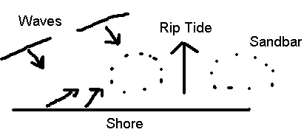

**Tides**

* rise and fall of sea level

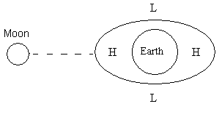

* caused by gravitational pull of the moon and sun
* tidal cycle= 24 hours and 50 minutes
* 2 high tides & 2 low tides a day approx. 6 HRs & 15 Min apart

**Types of Tides**

Spring tide-

occurs twice a month at full

and new moon

* Causes highest high tide and lowest low tide

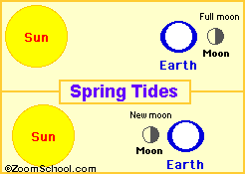

Neap tide-

occurs twice a month at 1st

and 3rd quarter

* Causes lowest high tide and lowest low tide

